**Experiment # 03**

**LED Running Lights with Light and Sound sensor**

Procedure:

1. Merge experiment 01 and Experiment 02, removing the LCD from experiment 02.
2. Now, with sensors attached in the Arduino board. We can have a display output using our LED array.
3. Using the data from the sensors gathered in experiment 02, run a pattern of running lights for every level of loudness in sound sensor and brightness in light sensor.

Source Code:

Circuit Diagram:

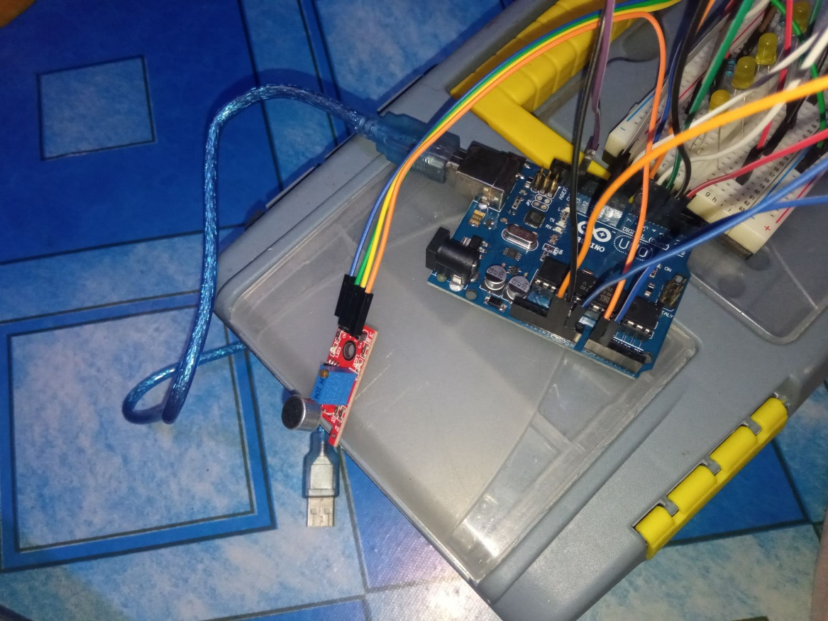

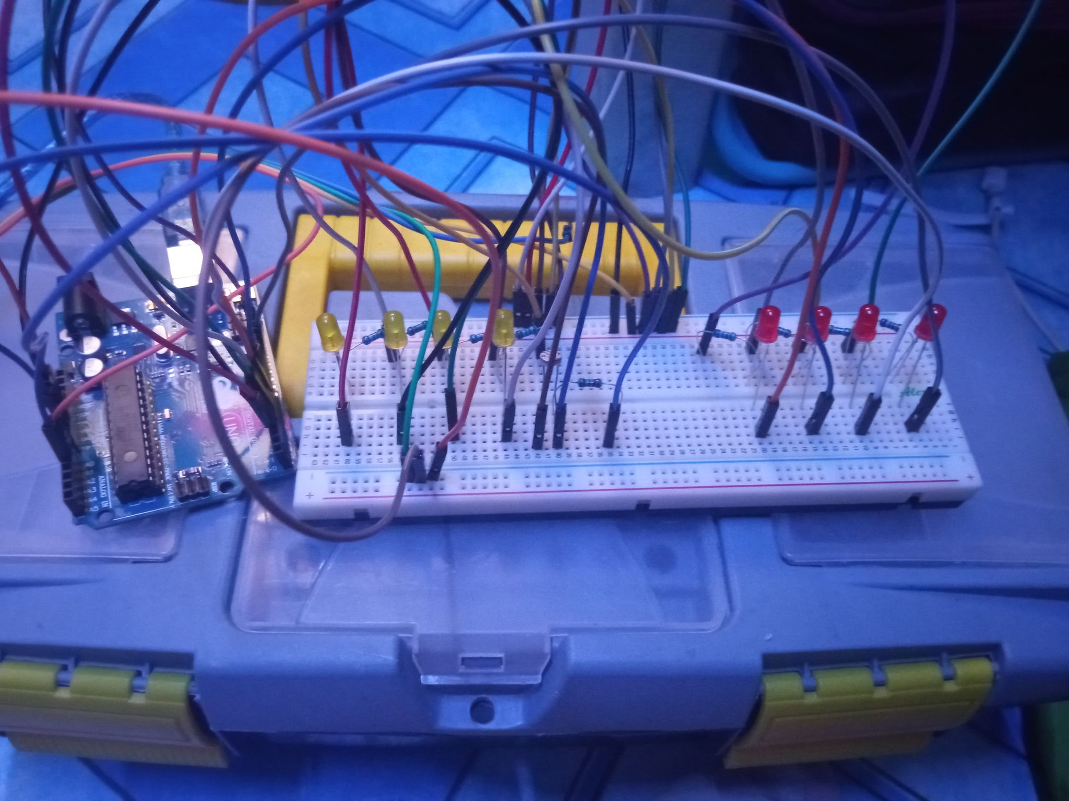

Observations:

1. It is hard to fit the circuit into the breadboard.
2. The source of the sound must be in front of the microphone.
3. The LDR part of the circuit gave excellent results.
4. All of the ground pins on the Arduino are used.